The Grizzly Beat
Transcript
Episode 21
Lyn Dalebout
Jan. 2017

Louisa Willcox: This is Louisa Willcox and welcome to the Grizzly Beat. We’re delighted to be here today with Lyn Dalebout, who is a long-term friend, and a poet and a writer and an educator. She’s also a biologist and a sidereal astrologer, who has lived in the Grand Tetons for most of her life. She studied at the University of Utah and Naropa University, and she’s worked with the Teton Science Schools for about 40 years, continuing to work with incoming graduate students and teachers. Lyn has a book of poems called Out of the Flames, Her writing has appeared in a number of anthologies, and she currently writes a weekly blog called Earth Sky Oracle. She has shared her poetry and performed her poetry widely at venues such as the Teton Music Festival and the Buffalo Field Campaign. She’s also the voice of Mardy Murie’s writings in the film “Arctic Dance”. Welcome, Lyn, to the show.

Lyn Dalebout: Thank you, Louisa. Thanks so much for this opportunity.

W: Yeah, absolutely. So Lyn, you’ve had a long and special relationship with wild animals in nature -- and these topics saturate your poems as well. If you could start off with a story from you early experience with a wild animal that perhaps shaped the direction that you took later.

D: Oh, right. That sounds great. I basically grew up in sort of a wooded neighborhood at the base of Mount Olympus in Salt Lake City. And I really just grew up in -- probably what I called back then was the “urban-wild”. We had a place in Alta, my second home, and we’d hike the trail in the Wasatch Mountains thanks to my parents…

But in all honesty, it’s when they would take us to Yellowstone -- and this was the first time I did actually encounter a bear. And I have those kinds of pictures that many of us do from those days of the 60s, where you actually have – I have pictures of us literally petting the bears and feeding them from our car, which of course is never allowed anymore. But back then, it was actually encouraged.

So all I know is that it was that early period in Yellowstone on every level that ignited that inner search. And then it wasn’t really until I got older, when I went out and started – I was a timber marker in Idaho, and then the Salmon wilderness for a long time -- and that’s when I first had face to face encounters with bears. And bears, I guess you’d say, are obviously my basic wild animal that I seek out and have always had a relationship with.

W: That’s great. I think we both share that sense of bears as the center of our lives. So Lyn --

D: And that’s something you and I that go again -- our friendship and how long it’s lasted, and your role in my life, you know, in terms of your inspiration as especially an activist leader, has been huge. And so you have many tales yourself I know.

W: Absolutely. Thanks, Lyn. So long ago you developed kind of a personal practice that relied on immersion in nature and wilderness as a spiritual inspiration for your poems and your writings and your performances. Can you share a bit about what that practice means to you, and how it started, and how it may have changed over time?

D: You bet. Sure. That comes again from that notion of who we innately are as children, and how our early experiences, I think, really truly inform us and deepen ways that we learn later in life.

And I do believe -- in general I think we all have an essential nature that we are born with. And mine seems to be listener first. I was like always coming in and listening to nature, getting out at dawn to hear the birds -- I still have my first Audubon bird book. I long ago lost my little binoculars, but listening in nature -- and that’s the essence of poetry which is why -- I consider as a writer, I always feel like poetry is my first language, and I wish I could write great novels and fiction… But in general I feel poetry is my “go to.”

And specifically I think my attunement has been -- what I’ve described myself sometimes is as an “earth listener.” I go out and sit for hours at a time, as Walt Whitman would encourage us to do, to just sit and let the sounds accrue to us, as he says -- and then the information arises and arrives. So this idea of sitting, waiting, being patient -- which is not necessarily part of my nature, but I think this practice has allowed me to become more patient. And then I was always a journaler, so I was always writing things down after the listening aspect.

W: Maybe you could share a poem that perhaps drew on one of these experiences.

D: Sure. I actually have a poem that’s called the “Vigor of Listening.” And I actually wrote this poem right after 9.11 It came to me -- I was teaching up in the Cody area. And so this is a poem that also came out of that time period. I think I wrote this on Sept. 16.

And I’ve also taught a class called the “Vigor of Listening.” So it is about this idea that listening isn’t just passive, it’s very vigorous, it’s very alive, it’s very -- it has it’s own power, right? But let me, if I could -- I’ll read just, this has seven different sections, I’m just going to read a few of these sections, kind of an excerpt if I could. And this is hopefully -- I’m working on a second book of poetry called Earth Is the Book and this is one of the poems that will be in that book.

Vigor of Listening
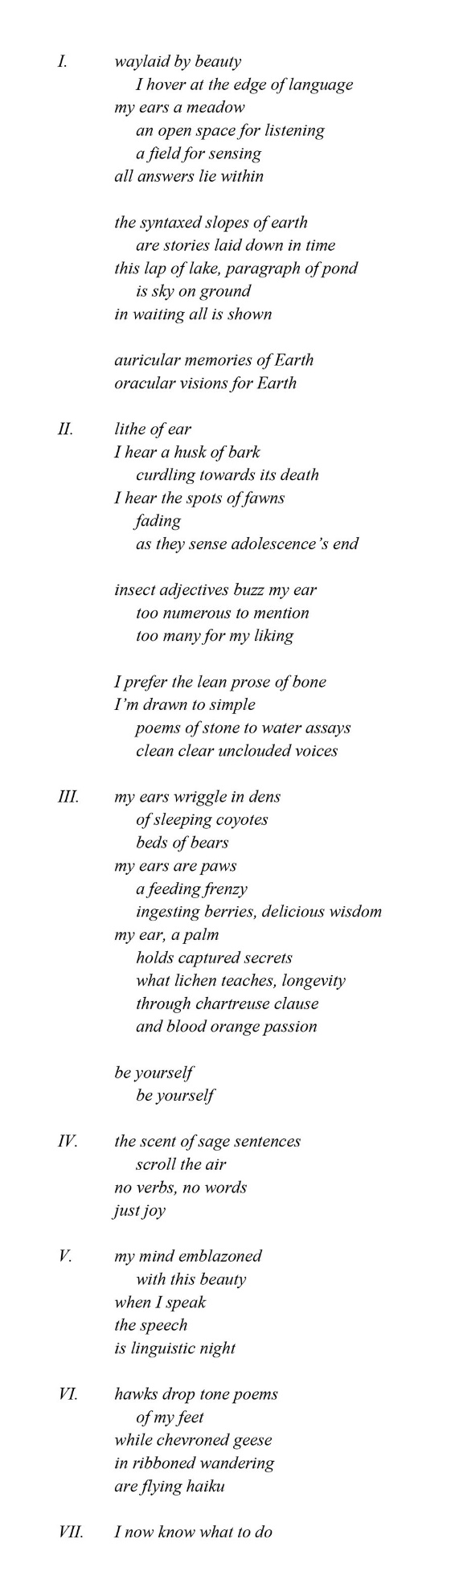

That’s the Vigor of listening.

W: Wow. So the story’s laid down in time.

D: Yes, I’ve always thought of geology that way. Those layers of -- I love to look to geology too, and Wordsworth said this, he talked about how poems are just waiting there to be, they’re waiting there to be grabbed. A poem is sitting there, and if you walk by, you’ll be the person that grabs it. So that’s another approach I’ve had to trying to find good poems.

W: Like a luscious fruit.

D: Yeah. I can’t remember, it was a famous musician, I’ll have to track that quote down, because it’s always stayed with me. It’s part of my own process.

W: Yeah. So Lyn, we shared an experience not too many months ago in Jackson, the land of your home. And we witnessed a treaty signing by a number of different Indian tribes in the West who are concerned about grizzly bears and the future of grizzly bears. And that tied into a dream that you had many years ago that helped shape your vision and who you are today. Can you talk about this experience?

D: It was so powerful -- and again to share that moment with you, Louisa, and it definitely makes me emotional thinking about the power of that day. Pardon me. And it was so moving, wasn’t it, to see that historic treaty being signed in this room in Jackson Lake Lodge and the hours of story-telling, etc. And again I do want to honor you for you greatly facilitated that happening, so thank you for being part of creating that this whole shift that’s coming on every level.

W: The tribes really did that. It was their doing. But we’re all grateful for that.

D: Exactly. And that we are now in this pause in the delisting process is huge and wonderful, and gives us again time to listen and take a deep breath. So yeah, in 1983, I was actually part of a performance art team and we were called the Headwaters Performing Arts Consortium -- and you know this because we actually performed at one of the events of Great Yellowstone Coalition when you were the director way back when, right?

W: Right.

D: And we even got to -- one year we were hired by Yellowstone to come and work with their interpreters and sort of bring arts into their interpretation, which… This is back in the early 80s, which was really fun.

And so as I was preparing to write something for that, I basically had a dream about this giant grizzly, it came to me it was like 25 feet tall. After the dream I called it the Pleistocene Bear, because it was just not a grizzly bear, not an earthly bear. And basically in that dream, it was this notion of -- I took dictation, and I wrote about it -- about guidance, inspiration from the element of Bear. And it’s like the door opened internally with that dream.

And over the years, I have had what I will come to call many shamanic dreams about Mother Bear -- and what I came to know her as was “Mother Bear.” And so when I heard the tribes talk about the Mother Bear, who was always their ancestral guide that came to them -- that is so tied to this question of “water is life” -- it just gave me chills.

And if I could read, there’s this one small section -- there’s this poem I wrote, this was back from that period back in 1983 called “In a Bear Voice.” So the voice came to me and here’s what it said, it said:

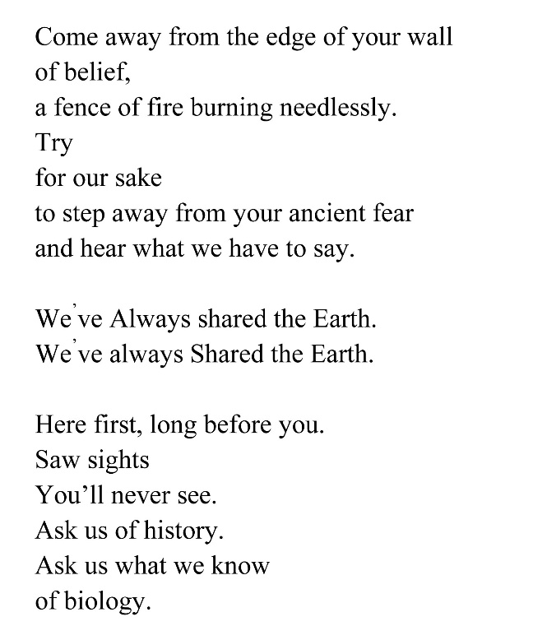

That poem was from that period.

W: Wow. Well, of course the native peoples had so many stories of the bears being their teacher -- and basically showing them what they could eat, and what plants were good for medicine. And they literally were teachers in their worldview.

D: Absolutely. I remember learning -- because I was studying botany in my biology degree – I was just always researching this idea of the link between the herbal components, such as green gentian, which comes up first in the spring, and that’s when the bears gorge themselves on it, and it causes a purge in your body. So learning about the plants and then also it’s form, which is natural medicine, which is also something Mother Bear has been the teacher of, for sure.

W: It’s phenomenal how powerful the dream of the bear, and the reality of the bear for tribal people has driven this unprecedented upwelling of concern about the Fish and Wildlife Service’s proposed delisting and the hunt. And I’ve never seen anything like what is going on with tribal people, who have really changed the political landscape. But it ties into their root view of bears as relatives and as teachers.

D: And finally -- I think that’s why that meeting for me was so emotional, and still is -- that link finally between the sacred and our politics.

And any time I, for instance, have gone up and given testimony before the interagency grizzly bear gatherings -- I always wanted to just speak to that idea of the sacred with the bears -- and I would, and then sometimes you feel it falls on deaf ears, and like: “Oh there she goes again.“ But nonetheless, we show up and we speak our truth.

And so when we see -- and of course the true authority of that voice, it comes through the Native American people. So the fact that they will be listened to, and are being listened to, and I really believe with this pause, more of that can come in. It’s what just has happened with all the activism with Bears Ears -- it did manifest, what a gift.

So it’s a turning point, absolutely. I feel that.

W: I feel that they have the potential to introduce into the political debate a sense of spirituality and sacredness that has been absolutely missing from the meetings over the years.

D: At some level I think everybody is hungry for that, or many people are hungry for that, even in the political process, and it’s trying to find a way to language: how do we honor that too, while still being scientists or agency people? It’s a tough job.

W: Yeah, it is absolutely a trick on navigating relationships with bears that many people have -- in fact the primary relationship with bears is not scientific for most people, they’re in the realm of spiritual, if you will, or related to the beauty of an experience. And I think agency people really don’t have much background in terms of orienting to people who have this very different connection -- that isn’t science, for most of us.

D: That’s interesting, because when I talk about the idea that sort of -- it was fun to be at the beginning of even bringing arts into the Park way back when. I’ve had thought maybe our next step is to bring that more spiritual component into -- even the Park Service. And that will come through the individuals who are in the Park.

But maybe they would bring in people but would say -- and I’ve worked with science schools for all these years – it’s okay now when you take kids out in the woods, to say, “let’s take a moment of silence.” I swear that wouldn’t have been okay way back in the day. So that’s a shift in our consciousness that I think is wonderful. And we need to model more of that so it becomes safer for people to do that.

W: Right. But speaking of the shift in consciousness, it seems to me that some of these celebrity bears that live by the roadsides in Jackson and Yellowstone Park have really been -- have really sparked the change, because people can see them now in a way that you couldn’t 25 years ago by the roads. And you had a special really special experience with a very famous bear, the matriarch 399, who was first spotted in the Jackson Hole valley somewhere in the early 2000s. Maybe you could talk about your experience with her, watching her raise her cubs, including last summer, when she had a new cub out with her. What did 399 and the bears in her family teach you?

D: Endless joy. Resonance, and just gratitude, for one thing. But yeah, I feel very fortunate, along with many of us who lived through, especially those early years of the 2000s. I really started watching her around 2006, 2007, and that’s when I became absolutely addicted.

I would go up as often as I could. I would hang out with 10 or up to 20 different people, but not that many of us were out there all the time watching. And remember there was no Wildlife Brigade yet. They were mainly photographers. Everybody was respectful. Yes, there was a sense sometimes of getting too close. And so what I’ve learned was absolutely how the bears were teaching us respect.

I mean 399, because she is, to me, the great matriarch and she has that calmness about her, versus her daughter 610, who is another favorite bear of mine, but is very fiery, bluff charges people. I was bluff charged by her once, from a safe distance. They have a different style of teaching, saying: “Hey, you’re going too close.”

And then a lot of that had to change, when all the sudden they became more famous and I want to tell a story about my favorite ranger Chris Flaugherty, who’d been there for years, you know Chris right?

W: No I don’t.

D: I talked with him, regularly chatted on the side of the road, and he had told me this story. This came out of a conversation I had last year. He was there basically when she came out as an orphan cub, 399. If I remember it was 2003. He was the one that kind of looked after her, kept her safe. And Chris was, in a sense, when it became kind of crazy -- he initiated the idea for a Wildlife Brigade.

But one story he did tell me that I thought was fascinating is that when she was – when 399 was first collared and weighed and tracked, she actually weighed 399 pounds.

Isn’t that interesting? And that wasn’t why she got that number, but that was a fun story to hear. So I just think she’s educating her cubs how to be around us. But I swear I saw her learn the “150 yard rule.”

Because she sort of knew exactly when she got too close -- she watched everybody freak out, especially certain people that would freak out -- not like me, when she would get closer. But people would be like: “uh oh, bring out those horns and whatever.” And then she would step back. And so I really feel, of course, and I know she’s so wise. And she is as much a teacher to us.

And I am forever indebted to her as being a roadside bear. Now I know that term is controversial, and I kind of consider it -- it’s more the bears that are more visible. Yes, there is science that says: “well they stay near the road, because their cubs feel more safe,” and that probably is true. And at the same time, I have this feeling about this, that if 399 is the earthly incarnation of that ancient Mother Bear –I have been writing about this -- she is just carrying that energy.

When they did -- they mistakenly trapped her this year again -- she was very healthy. She has the teeth of a bear that’s like 10 or 15 years younger. She’s an amazing bear, and I don’t know if we’ll have this kind of connection after these particular tribes of bears leave. Because it’s almost like it was an age of learning. So that will be interesting to see what happens in the future.

W: Yeah, and she’s getting old now, sort toward the end certainly her reproductive years at age of 20, which is a very, very old bear.

D: Yeah and yet she’s, maybe she’s -- you’re more on top of that, you and Dave know a lot more of that science than I do. But that was interesting to learn that she’s still got a lot of years in her, it sounds like to me.

W: Yeah, yeah. I mean if we would just keep the respectful behavior going and the like.

D: Absolutely.

W: So Lyn, shifting gears into another major love of your life, you’ve been an astrologer for many years, as long as I’ve known you, I think. How has your work in that field changed your perspective?

D: Let’s see. I kind of came to that totally out of the blue. I never ever in my life imagined I would even be an astrologer. And it is one of the ways I make a living, I think being that listener I spoke about.

I’ve always had a lifelong love of astronomy -- as much as the earth, I love staring at the planets, learning about them. In many places I’ve lived in Wyoming I’ve had to ski in in the middle of the night, and be guided by the stars literally, the beauty of the universe.

And when I had my chart read when I was younger -- I was still in college -- the information was so startling and true and shocking, that I just began a self-study. And so I’ve continued to work with that. I’m a sidereal astrologer, which means I work in real star time. So I work with the true galactic alignments over time.

I love to write about political astrology because I think when you analyze the charts of certain people, you see, again, the overall trend of a person’s soul – nothing is set in stone, the planets don’t cause things to happen -- it’s just a mirror. So that’s why, when I created my website or my blog, I call it “Earth Word,” which is really my poetry and writing, and then “Sky Word,” which is my astrology and sharing that. And then, again, the linking of the two is important to me.

W: Right. In the sky at night you can often see the Great Bear constellation, Ursa Major/Ursa Minor. And of course it’s connection to the North Star. And that constellation’s always had a special meaning for you. And maybe you could explain why.

D: Yeah -- and again that happened before I ever studied astrology. I was just like: “There it is, the Great Bear.” That was obviously -- I love Ursa Major, especially Ursa Major, because it is the Great Bear.

But it also -- as you study it from the storied perspective of astrology, it’s all about the right use of power. So it is actually associated with either kind of “over-power” people and control them from the outside using external force. And it was -- if you go back in astronomy and study it, it was, during a certain period of time, it was sort of our ruling constellation. And that would be back in the day when there was brute force, and empires, and tremendous use of warfare and force.

But it also symbolizes “to be empowered from within.” Which is again, to me, why the Great Bear comes to us. It’s about knowing your power from within. Knowing your inner power and your gift.

And so that’s, to me, the difference between power and force. Are you someone who comes from your inner power -- you trust that, you’re calm with that. Or is it trying to work from this old way of forcing things?

I think personally that’s one of the reasons that grizzlies in particular evoke this sense of either unwarranted fear -- and yes, you’d have to be respectful, keep your distance -- but there’s such unwarranted fear. Which certainly -- whenever I’m out there and talking to people, I try and talk them down from their fear.

And then there is also the extraordinary respect, because I do think grizzlies can actually help us heal our fears. And that’s what my grizzly bear dreams over the years have been, they’ve always been about -- they sort of come when I’m dealing with a fear that needs to be addressed and cleared, and then coming back into a place of trust and love. So clearing fear and coming back into love.

And also knowing your power and not having to overpower somebody. Being confident that: speak your truth, stand your ground, and then let it go, and let it be heard. I don’t know if that makes sense but that’s how I put it all together.

W: Well, you certainly see fear and the need to control color a lot of grizzly bear management in the present time. I think it’s changing, but certainly this need to dominate these wild animals has been at the root of a lot of how we handle bears.

And maybe we can just shift briefly into the story of one of 399’s descendants, a bear with the number of 760. And that bear was moved a couple years ago from Jackson where he had been born and raised and lived, to the Cody area, where it was killed by a Wyoming Game and Fish official -- even though it had not really committed the kind of sin that typically results in bear managers killing them, such as attacking somebody or damaging livestock. Can you talk about what 760 meant to you, and then can you talk about maybe a little bit about the management side of things?

D: His was a great sacrifice, so sad. So he was one of 610’s sons and I watched him hang around in different places. He was not a troublesome bear, and he loved to roam. He was a roamer, especially once he got kicked out of the nest. He would roam all the way up to Yellowstone and then he got into trouble. He roamed all the way down to Wilson, and I believe was collared or caught twice so then the third time -- the fact that it happened in the late fall and he was not given a chance to be relocated back to Grassy Lake where he most likely would have just gone into hibernation -- it was that time of year.

It was such a tragedy. And it just sparked so many of us, including my dear friend Cindy Campbell who that next day started the 760 facebook page, which really has gathered community, and activated a community from around the world. She and I met with -- we felt just obligated to go and meet with Wyoming Game and Fish. And we met with them a couple times just to share our views about the mistakes in management, and at the same time trying to listen, to understand their decision-making process.

Because as you said Louisa, I don’t feel that, at some level, I understand where, when you’re in an agency, that the whole idea of protecting the humans is always seems to be number 1, or hunting. So just to go in and talk to them about that. And it was -- the first conversation especially was long -- and it was a very good conversation. And I want to continue that with certain members in that community.

But then Cindy and I, we created a memorial service in the spring after he was killed. And that was very powerful as well, including the people that showed up from the Park, it was very moving. People that really surprised me actually. One of the Wildlife Brigade people I didn’t imagine would come and he came. And it was just really very moving and it was about honoring the sacred of the bear, the sacred space that bear held.

W: Right. Maybe you can share a poem that you read at the memorial in Grand Teton Park last year.

D: I would love to because this is my -- thank you, I would love to. This is the poem for the Grand Teton grizzlies, and it’s a whole poem about Ursa Major/Ursa Minor. So I actually wrote this way before 760, but then I read this at the memorial. And we created -- Cindy created -- this beautiful memorial art. Once again art is activism and honoring.

And our friend Michelle McCormack donated her time to create this beautiful piece of art that literally has gone around the world. So this poem is called Seven Stars for Seven Bears. A praise poem for Teton grizzlies. Again my apologies in advance, probably -- you know me I’m a crier, Louisa.

W: Fine. That’s fine.

D: I get so emotional. Okay, so. Hopefully I’ll get through this though.

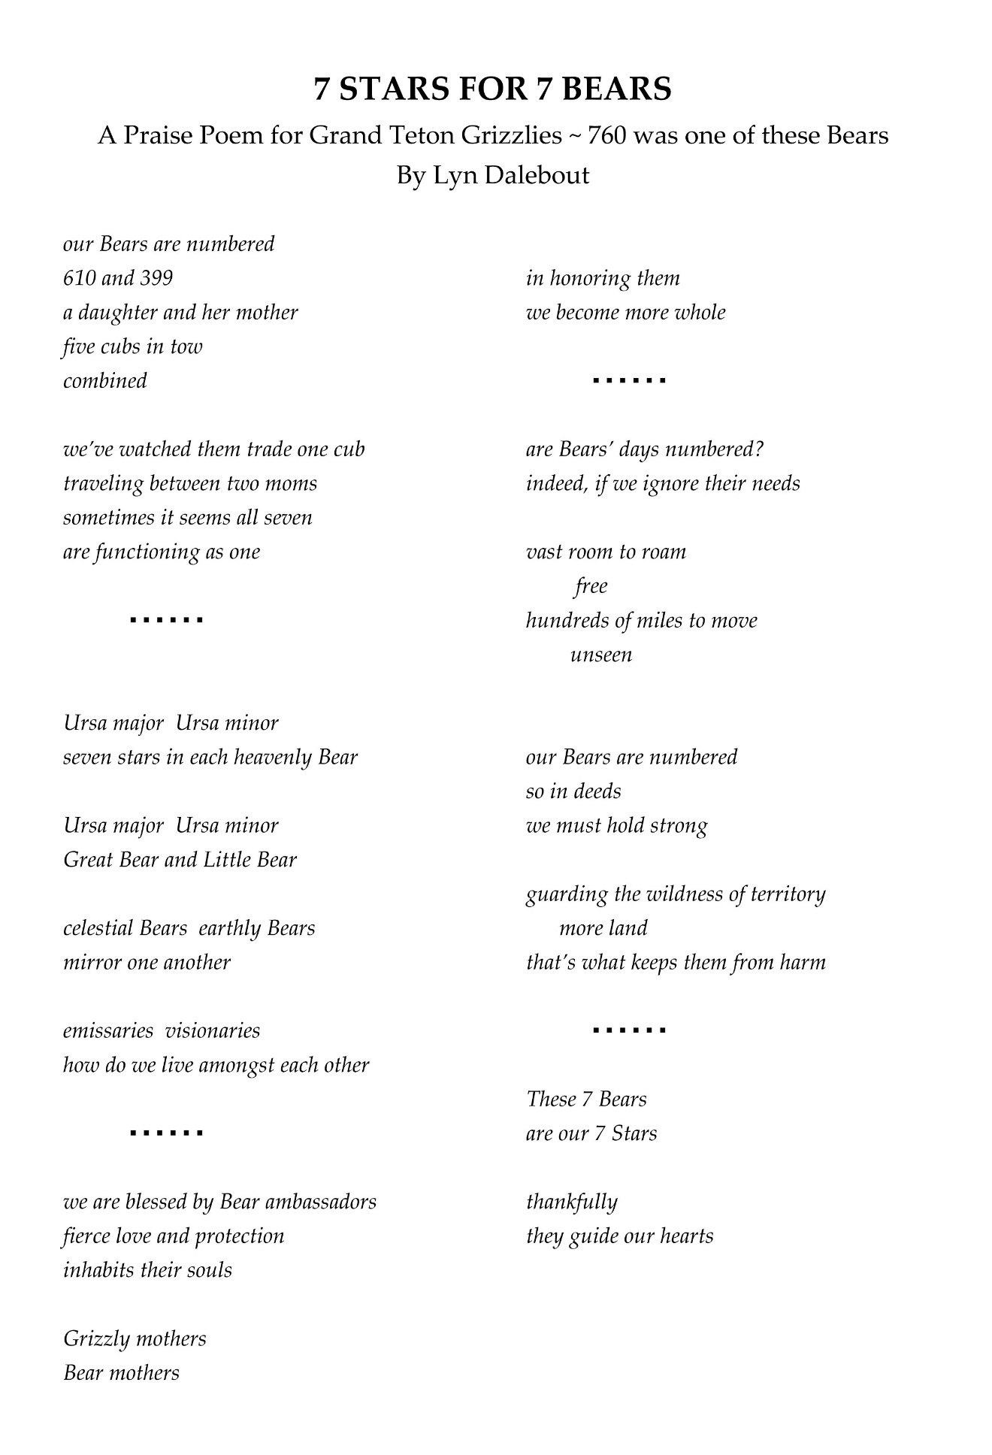

W: Wow, I wish I’d been at your memorial. So when you mentioned a moment ago that art to you is a form of activism, and that we all have responsibility to play some kind of role in making this world a better place for nature and ourselves. Maybe you could talk a little bit more about what you mean by “art as activism.”

D: The idea of creativity -- and when I say “art” at some level, maybe I should even say “creativity.” Because I consider scientists some of the most creative people I know, especially when they’re willing to think outside the box and really be creative with interpreting the data, for instance. Or a chef who’s creating something. So this idea of using your creativity, your talents, whatever they are, and being on, getting on board with what you love and care about. And I just personally have no doubt that the whole essence of activism is moving toward -- thanks to social media -- that people can get more active in their creativity and influence change.

And it takes time. So it’s sort of like this process of educating people, not just fighting, but putting out something that’s new and inspirational. Not just fighting and attacking. So inspiring people. Getting them excited to love bears.

I’ll never forget, one time I was standing at the top of Dunraven Pass, and we were watching one of their great roadside grizzlies, and this biker from the Midwest pulls up and he’s watching the bear -- I lent him my binocs and at the end of it he goes: “Don’t you just – feel more wild when you watch that bear? I just feel like I’m wild when I watch that bear. I just love that bear.”

And it was like that moment just -- he got it, ya know? I have no doubt he went back and became an activist just by that contact. So using art that, you know, as a forum to create change. And then I was looking to tie it in with the incredible speech that Obama gave, as his final speech the other night. His quote which was: “the most important office in a democracy is citizen.” So that’s where we’re going now, taking that role and that power we have as individuals to inspire change out of what we love.

W: Right. Well, certainly Obama drove that point home the other night, and actually through his presidency. And this maybe gets -- maybe we can shift gears a little bit, because you’ve been a political player and an activist for as long as I’ve known you. And I’m just kind of curious about how you see politics as a mirror that reflects what’s happening in the stars and the sky. Maybe you could share your thoughts on that and share an example or two.

D: Well, in all honesty, I feel like I’m not -- I wish sometimes I was more out in the streets, you know, and running a nonprofit. I mean, I thought I might be running a nonprofit at some point, but then I think coming back to that idea of what is your essential nature? What is it that you love to do? How do you want to interact with this?

And so one thing I’ve discovered is that through astrology, I really can write about politics and people -- yes some people get pissed, like I just wrote a whole piece on the chart of the incoming president-elect and I, you know, I laid it out as I saw it. And I think that information can be valuable for people. And yes I have a lens through which I see.

And I am going to write, as my final tribute for President Obama, I am going to write about his chart and publish it on Jan. 20, because he has been, as I call him, “the Educator in Chief.”

So I think that my form of activism is also changing right now -- for all of us. I mean I’ve just been in a deep internal space since November, just going: “What’s next? What do I do next personally? What do we do next?” But also because of that, what is my role, and how can I assist?

And so when he talked about that as “citizen,” you think: “These are revolutionary times.” And we’re coming into a time when there’s going to be, in my opinion, a chaotic alarming lack of leadership from the top. So we will all be finding out new power and voices and gift.

And that will be exciting, and that will be a beautiful thing that comes about in the next years to “walk our talk” at a higher level of personal integrity. To model that, to mirror that. And that in general, to me, is what for the most part President Obama mirrored, was this idea of taking ourselves to a higher plane -- becoming more compassionate, becoming more inclusive, protecting the great earth.

And my primary focus will always be the earth, it just is. And maybe this idea of how to help the humans evolve at a more rapid pace. I really place my ultimate faith in the earth and the heavens. And it’s – we’re going forward. The track of the universe is progress.

There’s one thing I like the remind people: planetary motion is two steps forward, one step back, retrograde. So the planet goes forward a certain degree, and then one step back. So that retrograde period is -- what you want to do when that happens is integrate and reform.

And once I saw that -- it’s what allows me to have faith and trust that we’re going retrograde, going back over things, revisiting, revamping, so that when the next hit of the progressive movement comes, we’re really ready. And so that’s the way I deal with my sadness and grief and upset on certain days. But I do just believe in all of us. We, our community, is so powerful. It’s just time to get more active and activated.

W: And certainly there’s an urgency with how rapidly we’re changing the planet, to radically change the ability of this planet to be inhabited by people let alone wildlife and nature. So there is a sense of urgency to move forward, it seems. So as you look forward to this new trajectory and new political climate that we’re in, what’s the role of bear power in all of that?

D: Again, bear to me is the love of power or the power of love. Sometimes I have this -- maybe I’ll turn this into a book because it would be a fun kids’ book -- I get this feeling when I watch 399, maybe she is a little tired of raising batches of triplets all the time. And then after, there is no doubt the loss she faced with [her cub]Snowy’s death. We experienced her heartbreak. We got to watch her return those two days after…

And so this sense of -- even her – is she going to become the philosopher bear? And she’s going to be teaching us new things. And maybe she’ll come more to us in our dreams, and maybe more people will be having these dreams. But bear power is so much about knowing your inner strength. It’s not wolf, which is very tribal and communal, it’s knowing your inner power and protecting what you love. That’s what bear is.

W: Well on that note, Lyn this has been a great conversation. We’re here today with Lyn Dalebout and the Grizzly Beat. Thank you, Lyn, so much.

D: Thank you.

